

**ARIGNAR ANNA GOVERNMENT ARTS COLLEGE VILLUPURAM**

**DEPARTMENT OF STATISTICS**

**NAAN MUDHALVAN PROJECT**

**3RD YEAR B.SC STATISTICS**

**SHIFT-1**

**JOB APPLICATION TRACKIN SYSTEM**

**TAEM LEAEDER : VIJAYKUMAR**

**TEAM MEMBER:**

1. **Sunthar**
2. **Sridhar**
3. **Sunilkumar**

**TEAM LEADER – vijaykumar**

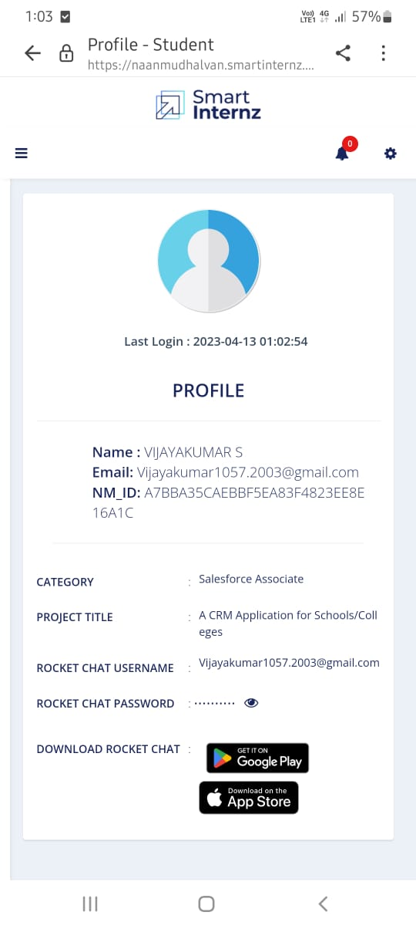

**Team member :**

**1 . Sunthar**

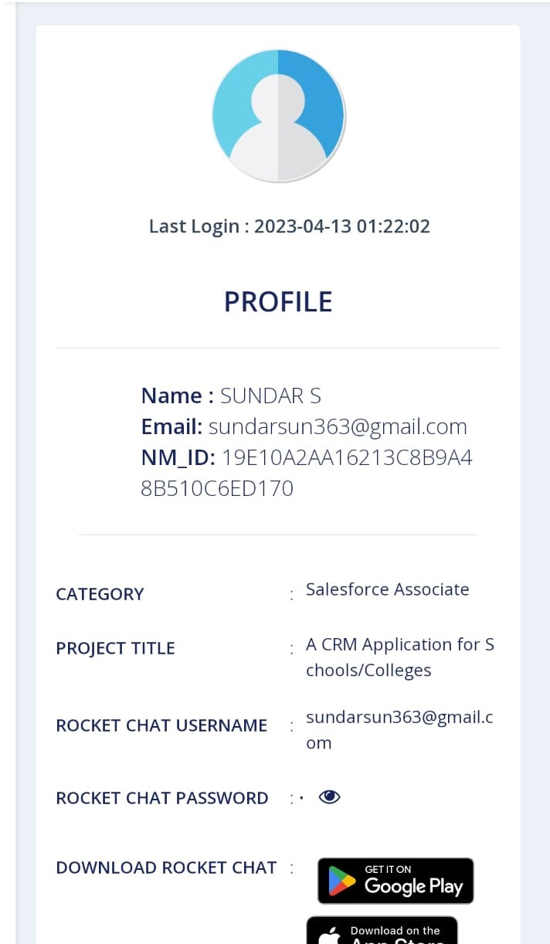

**2 . Sridhar**

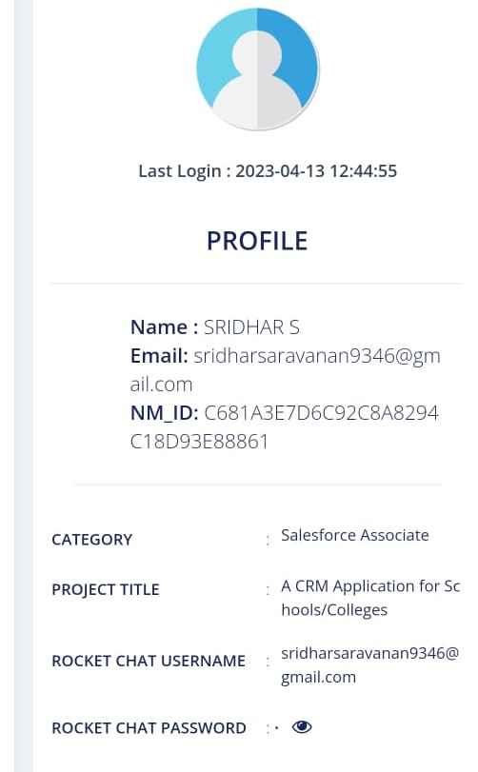

**3 . Sunilkumar**

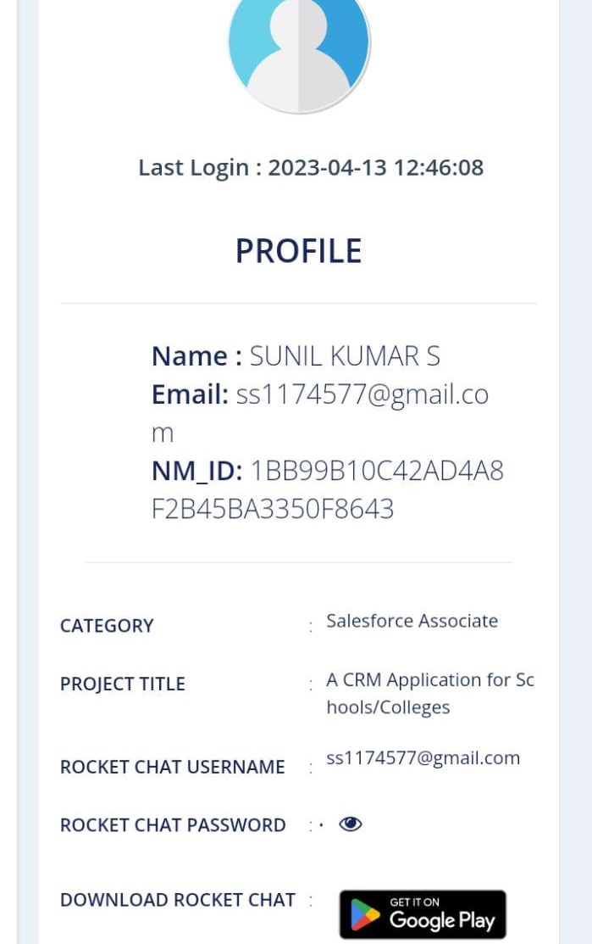

**1. INTRODUCTION**

**1.1 Overview**

Naan Mudhalvan platform aims to provide dynamic

information for college students on courses and relevant information

about industry specific skill offerings.

This will enable the students of TamilNadu to get training in their

chosen field of interest that will help them in achieving their career

goals.

The objective of this scheme is to identify potential training providers,

to impart various skill trainings based on current industry gaps.

Through this flagship program the students will be able to get trained

and ensure they get jobs according to their skill sets. We will also offer

career and academic guidance to students in state educational

institutions.

Naan Mudhalvan showcases 2000+ institutes and consequent 300+

career pathways**.**

**1.2 Purpose**

This Project use for more skills for Students in our Life.

* Salesforce

* Trailblazer

This program offers training in coding and robotics, as well as

guidance in nutrition, physical fitness, and overall development from

psychological counselors and therapists. Both in-person and virtual

training options will be available. A Guidance Bureau will be

established in every school to implement this program**.**

**2. Problem Definition & Design Thinking**

**2.1 Empathy Map**

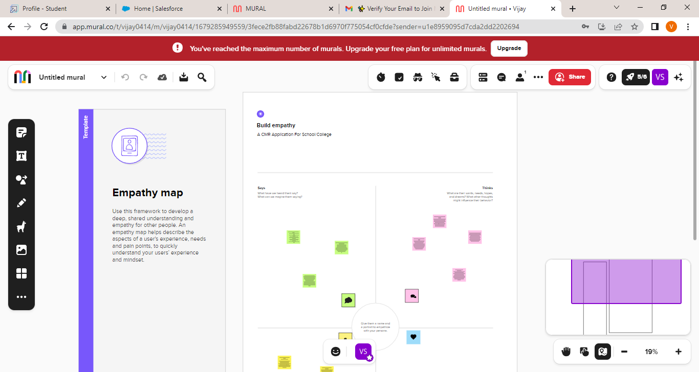

**2.2 Ideation & Brainstorming Map**

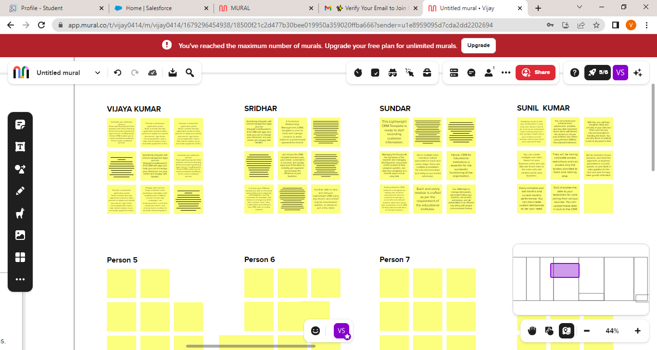

3. RESULT

3.1 Data modal:

**1.Creation Of Developer Account**

A Developer org has all the features and licenses you need to get started with Salesforce.

1. Search <https://developer.salesforce.com/>

2.Enter the following details like First name, last name, Email, Role, Company, Country/Region, Postal code, and Username must be unique.

3. Click sign me up, After a few min you will reserve a mail salesforce org and by using the verify account link you can create your new password.

4. Click save.

5. Search <https://login.salesforce.com/>

6. By using username and password you can into the salesforce org.  
The setup page will appear as below.  
Create a developer org and login with your login credentials.

**Creation Of School Object**

**Creation of Objects for School Management:**

For this school management we need to create 3 objects i.e school,parents and students.

The below steps will assist you in creating those objects.

1. Click on the gear icon and then select Setup.

2. Click on the object manager tab just beside the home tab.

3. After the above steps, have a look on the extreme right you will find a Create Dropdown

click on that and select Custom Object.

a. On the Custom Object Definition page, create the object as follows:

b. Label: School

c. Plural Label: Schools

d. Record Name: School Name

e. Check the Allow Reports checkbox

f. Check the Allow Search checkbox

g. Click Save.

Now create a custom tab. Click the Home tab, enter Tabs in Quick Find and select Tabs.

Under Custom Object Tabs, click New.

1. For Object, select School.

2. For Tab Style, select any icon.

3. Leave all defaults as is. Click Next, Next, and Save.  
  
In the same way create other objects such as students and parents.

**Create Student Object**

1. Click on the gear icon and then select Setup.

2. Click on the object manager tab just beside the home tab.

3. After the above steps, have a look on the extreme right you will find a Create Dropdown

click on that and select Custom Object.

a. On the Custom Object Definition page, create the object as follows:

b. Plural Label: Students

c. Record Name: Student Name

d. Check the Allow Reports checkbox

e. Check the Allow Search checkbox

f. Click Save.

Now create a custom tab. Click the Home tab, enter Tabs in Quick Find and select Tabs.

Under Custom Object Tabs, click New.

1. For Object, select Students.

2. For Tab Style, select any icon.

3. Leave all defaults as is. Click Next, Next, and Save.

**Create Parent Object**

1. Click on the gear icon and then select Setup.

2. Click on the object manager tab just beside the home tab.

3. After the above steps, have a look on the extreme right you will find a Create Dropdown

click on that and select Custom Object.

a. On the Custom Object Definition page, create the object as follows:

b. Label: Parent

c. Plural Label: Parents

d. Record Name: Parent Name

e. Check the Allow Reports checkbox

f. Check the Allow Search checkbox

g. Click Save.

Now create a custom tab. Click the Home tab, enter Tabs in Quick Find and select Tabs.

Under Custom Object Tabs, click New.

1. For Object, select Parents.

2. For Tab Style, select any icon.

3. Leave all defaults as is. Click Next, Next, and Save.

**Create The School Management App**

1. From Setup, enter App Manager in the Quick Find and select App Manager.  
  
2. Click New Lightning App. Enter School Management as the App Name, then click Next

3. Under App Options, leave the default selections and click Next.

4. Under Utility Items, leave as is and click Next.

5. From Available Items, select Schools, Students, Parents, Reports, and Dashboards and move them to Selected Items. Click Next.

6.From Available Profiles, select System Administrator and move it to Selected Profiles.

Click Save & Finish.  
  
7. To verify your changes, click the App Launcher, type School Management and select the

School Management app.

**Note:**

1. App Launcher-Displays available apps.

2. App Name-Displays the current selected app.

3. Navigation menu-Displays the tabs available inside the app.

**Creation Of Fields For The School Objects**

1. click the gear icon and select Setup. This launches Setup in a new tab.

2. Click the Object Manager tab next to Home.

3. Select School.

4. Select Fields & Relationships from the left navigation, and click New

**Now we're ready to make a custom field. Let's do this!**

1. Select the Text Area as the Data Type, then click Next.

2. For Field Label, enter Address.

3. Click Next, Next, then Save & New.

4. Follow steps 1 through 3 and create two more text areas with District,State and School

websites as the field labels.

**Now let's create the other fields and we must choose the data types of the fields carefully .Let's**

**have a look at it.**

For example, a phone number is a number field. For that we need to select the phone as data type

1. Select the Phone as the Data Type, then click Next.

2. For Field Label, enter Phone Number.

3. Click Next, Next, then Save & New.

**Lets create Roll-up summary fields to calculate the number of students**

1. From Setup, click Object Manager and select School.

2. Click Fields & Relationships, then New.

3. Select the Roll-up summary field as data type

4. Enter the field label as Number of students

5. Click Next

6. Then select the master object summarized as students and then select count as roll-up and then click Next,Next and save.

1. From Setup, click Object Manager and select School.

2. Click Fields & Relationships, then New.

3. Select the Roll-up summary field as data type

4. Enter the field label as Highest Marks

5. Click Next

6. Then select the master object summarized as students and then select Max as roll-up and

then select Marks as field to aggregate. click Next, Next and save.

**Creation Of Fields For The Student Objects**

1. Select the Phone as the Data Type, then click Next.

2. For Field Label, enter Phone Number.

3. Click Next, Next, then Save & New

**Let's create a master-detail relationship with school object**

1. Select Master-Detail Relationship as the Data Type and click Next.

2. For Related to, enter School.

3. Click Next.

4. For Field Label, enter School.

5. Click Next, Next, Next and Save.

**Lets create a Pick-List field:**

1. From Setup, click Object Manager and select Student.

2. Click Fields & Relationships, then New.

3. Select Picklist as the Data Type and click Next.

4. For Field Label enter Results.

5. Select Enter values, with each value separated by a new line and enter these values:

6. Pass

7. Fail

8. Click Next, Next, then Save & New

**Lets create a Number field:**

1. Select the Number as the Data Type, then click Next.

2. For Field Label, enter Class.

3. Click Next, Next, then Save & New

4. Follow steps 1 through 3 and create one more number field with Marks as the field labels.

**Creation Of Fields For The Parent Objects**

1. Select the Text Area as the Data Type, then click Next.

2. For Field Label, enter Parent Address.

3. Click Next, Next, then Save & New.

4. Select the Phone as the Data Type, then click Next.

5. For Field Label, enter Parent Number.

6. Click Next, Next, then Save & New

**Creation On Profile**

From Setup enter Profiles in the Quick Find box, and select Profiles.

1. From the list of profiles, find Standard User.

2. Click Clone.  
  
3. For Profile Name, enter School profile.

4. Click Save.

5. While still on the School profile page, then click Edit.

6. Scroll down to Custom Object Permissions and Give view all access permissions and

assign to the parent profile

**Creating A Users**

1. From Setup, in the Quick Find box, enter Users, and then select Users.

2. Click New User.

3. Enter the user’s name Parents and (Your) email address and a unique username in the form of an email address. By default, the username is the same as the email address.

4. Select a User License As salesforce.

5. Select a profile as a School profile.

6. Check Generate new password and notify the user immediately to have the user’s login name and a temporary password emailed to your email.

7. Similarly follow the above steps and create 3 users as Teachers and principals.

**Permission Sets 1**

1. From Setup, enter Permission Sets in the Quick Find box, then select Permission Sets.

2. Click New.

3. Give the name of the Permission set name as teacher permission and then under the object settings give the view create and edit permissions to all custom objects and assign to the teacher user  
  
Similarly follow the above steps for the permission set 2.

**Permission Sets 2**

1. From Setup, enter Permission Sets in the Quick Find box, then select Permission Sets.

2. Click New.

3. GIve the name of the Permission set name as Principal permission and then under the object settings give all permissions for the custom objects and assign them to the Principal user.

**Reports**

1. From the Reports tab, click New Report.

2. Select the report type as School with students and parents for the report, and click Create.

3. Customize your report, then save or run it.

**3.2 Activity & screenshot**

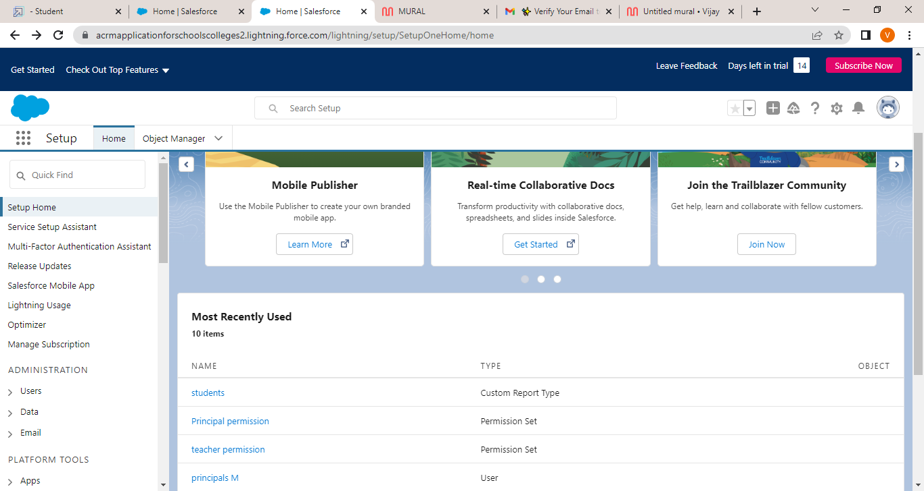

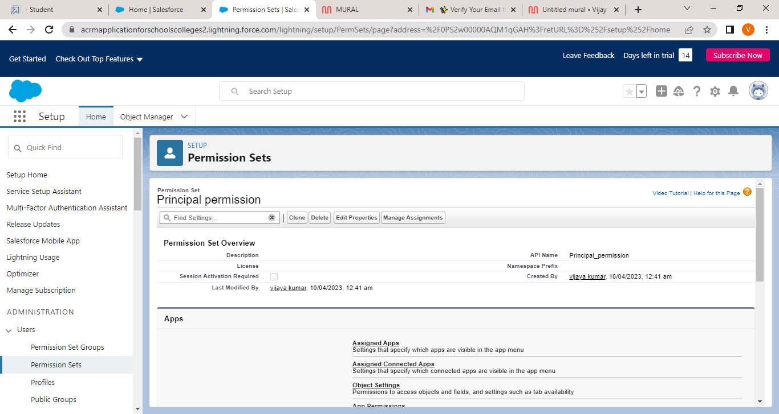

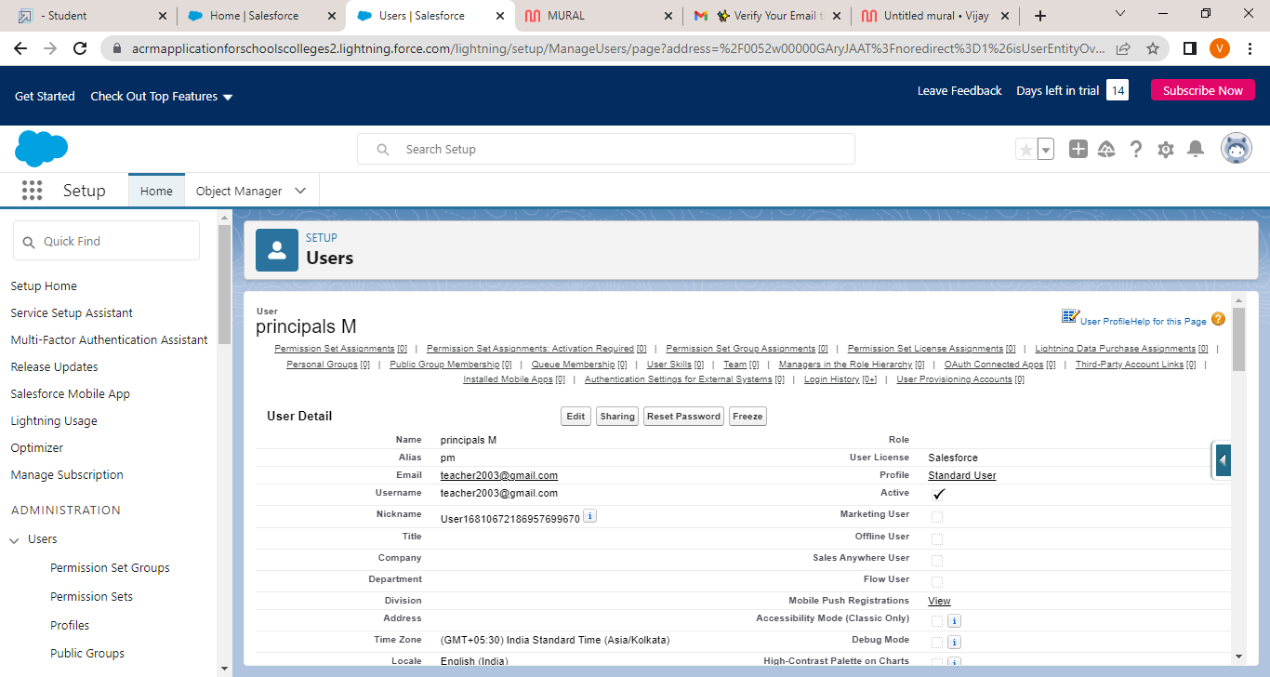

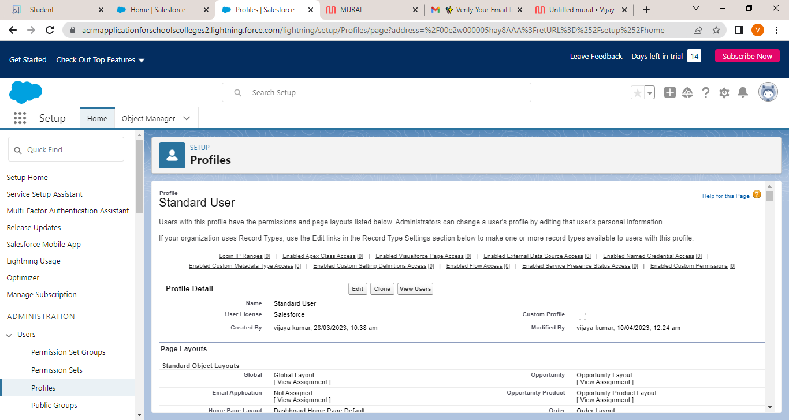

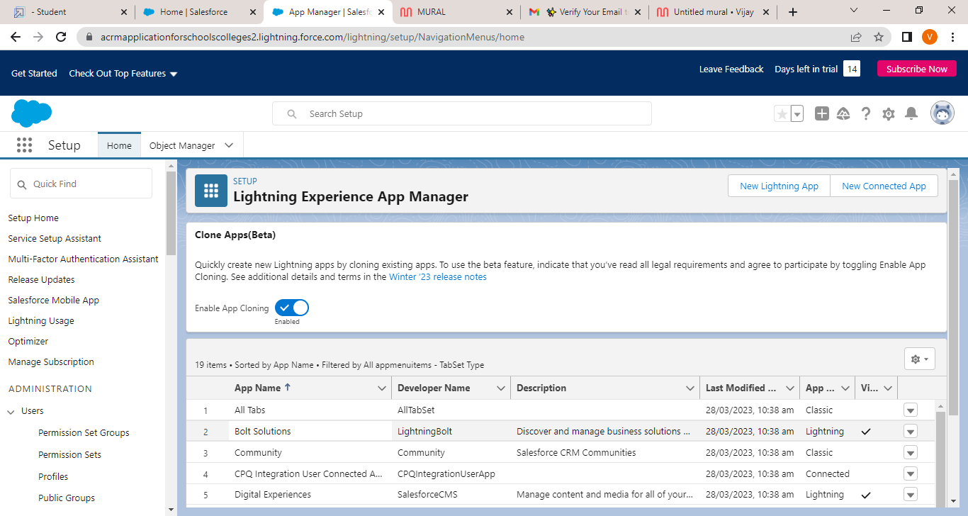

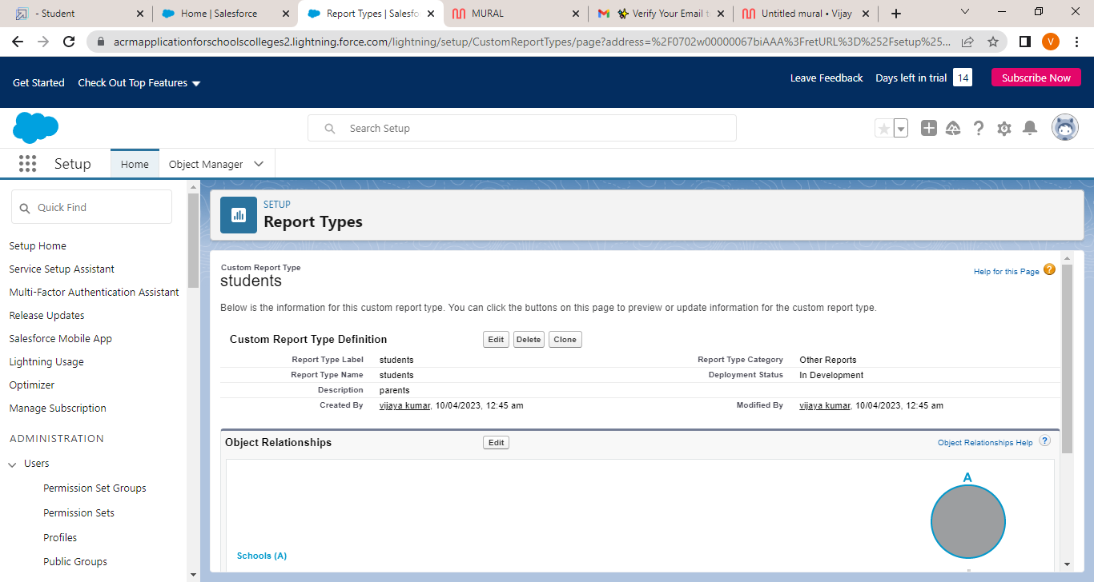

**4. Trailhead profile public URL**

Team ID **:**  A7BBA35CAEBBF5EA83F4823EE8E16A1C

Team Size : 4

**Team Leader**

Vijaykumar - **https://trailblazer.me/id/vkumar3369**

**Team member ;**

**1.Sunthar -** [**https://trailblazer.me/id/susun24**](https://trailblazer.me/id/susun24)

**2.Sunilkumar -** [**https://trailblazer.me/id/sunis38**](https://trailblazer.me/id/sunis38)

**3. Srithar -** [**https://trailblazer.me/id/ssridhar111**](https://trailblazer.me/id/ssridhar111)

**5.ADVANTAGES & DISADVANTAGES**

**ADVANTADE:**

**An efficient dashboard streamlines sales activities Potential to add revenue Allows for easier collaboration Enables automation of repetitive tasks**

**Improved Informational Organization. ...**

**CRM for Enhanced Communication. ...**

**CRM Improves Your Customer Service. ...**

**Automation of Everyday Tasks. ...**

**Greater efficiency for multiple teams. ...**

**Improved Analytical Data and Reporting**

**DISADVANTAGES :**

1. **CRM costs. One of the greatest challenges to CRM implementation is cost. ...**
2. **Business culture. A lack of commitment or resistance to cultural change from**
3. **people within the company can cause major difficulties with CRM implementation. ...**
4. **Poor communication. ...**
5. **Lack of leadership.**
6. **. APPLICATIONS**

**A CRM is a system that helps schools manage the entire lifecycle of a potential customer — sometimes also referred to as a lead. With a CRM, you can track and store the data that's important to your operations, all in one easy-to-access place.**

**The best CRM software for K-12 educational institutes is LeadSquared. It provides tools for enrollment management, marketing automation (automated communication via WhatsApp, email, SMS, etc.), and a parent portal in a single platform**

1. **CONCLUSION :**

**Conclusion. Customer Relationship Management enables a company to align its strategy with the needs of the customer in order to best meet those needs and thus ensure long-term customer loyalty**

**In conclusion, customer care, involves the use of basic ethics and any company who wants to have success and grow, needs to remember, that in order to do so, it must begin with establishing a code of ethics in regards to how each employee is to handle the dealing with customers.**

1. **FUTURE SCOP:**

**Customers will become a company's best sales reps through superior products and services as well as customer-oriented messaging. The future of CRM is more than just the future of Customer Relationship Management software. It is really the future of business.**

**Customer relationship management (CRM) is the combination of practices, strategies and technologies that companies use to manage and analyze customer interactions and data throughout the customer lifecycle. The goal is to improve customer service relationships and assist in customer retention and drive sales growth.**